Set up Development environment for MetaFabricAI and Developed the FrontEnd

Install Git
https://git-scm.com/install/windows

Install Node.js
https://nodejs.org/en/download

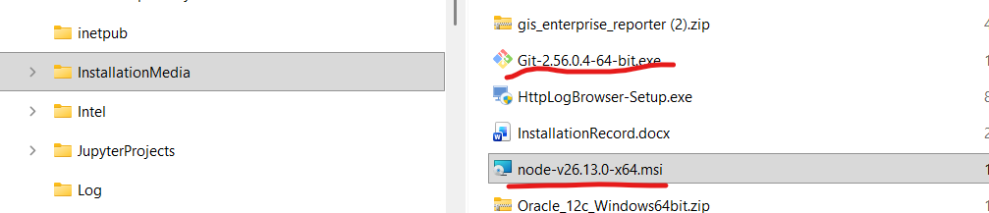
Install muse
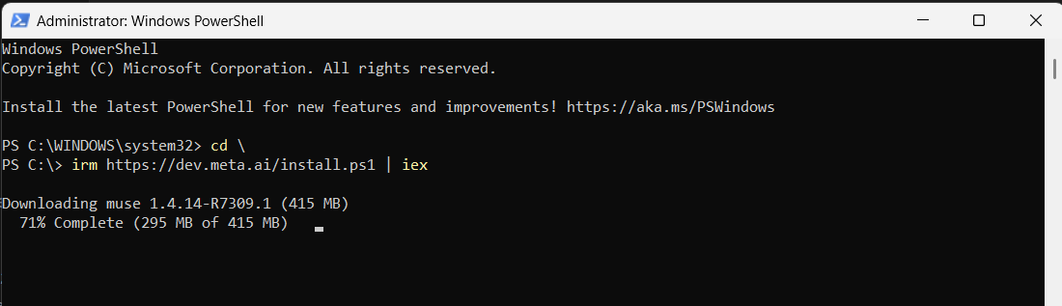
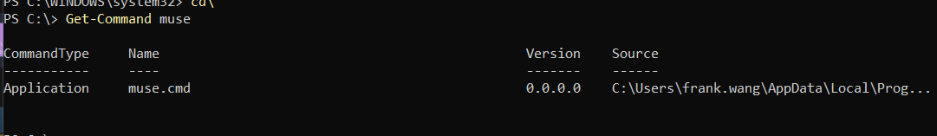

Check python in powershell:
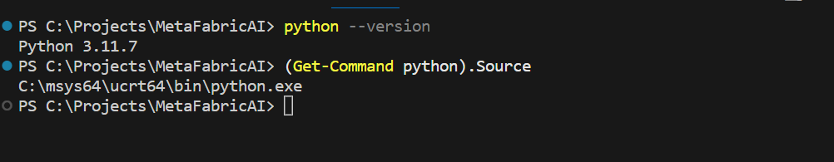

Install python install manager
https://www.python.org/downloads/release/pymanager-264/
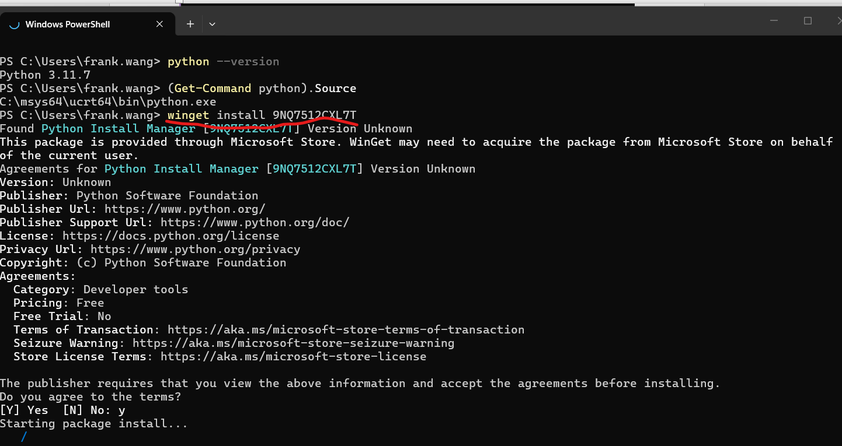

Use Muse:
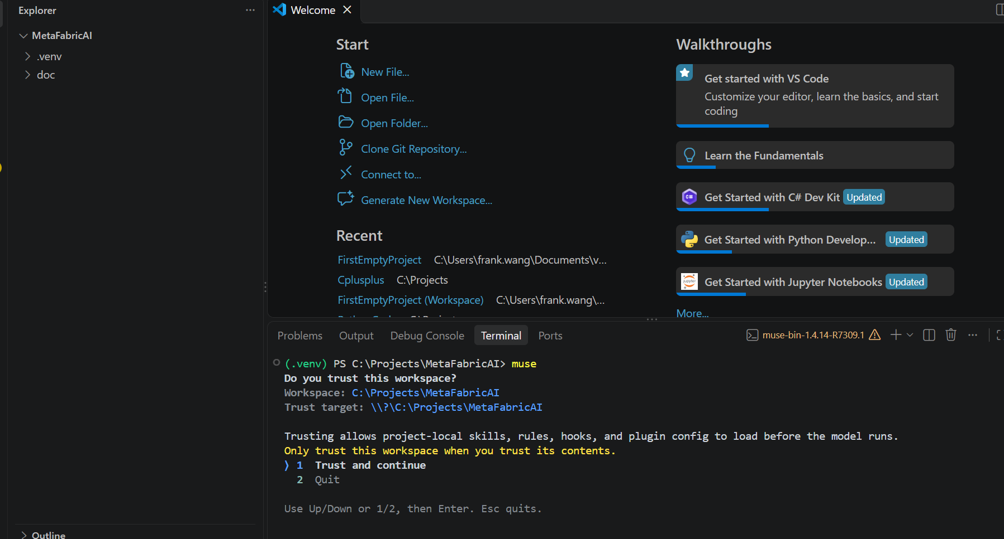

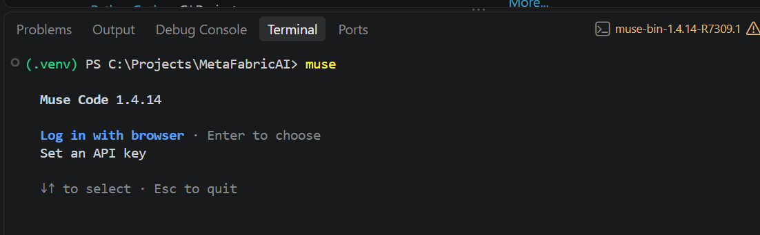
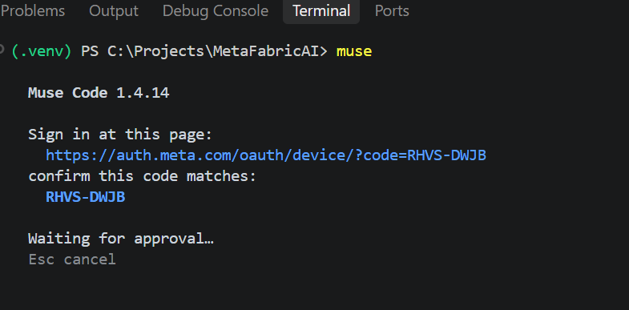
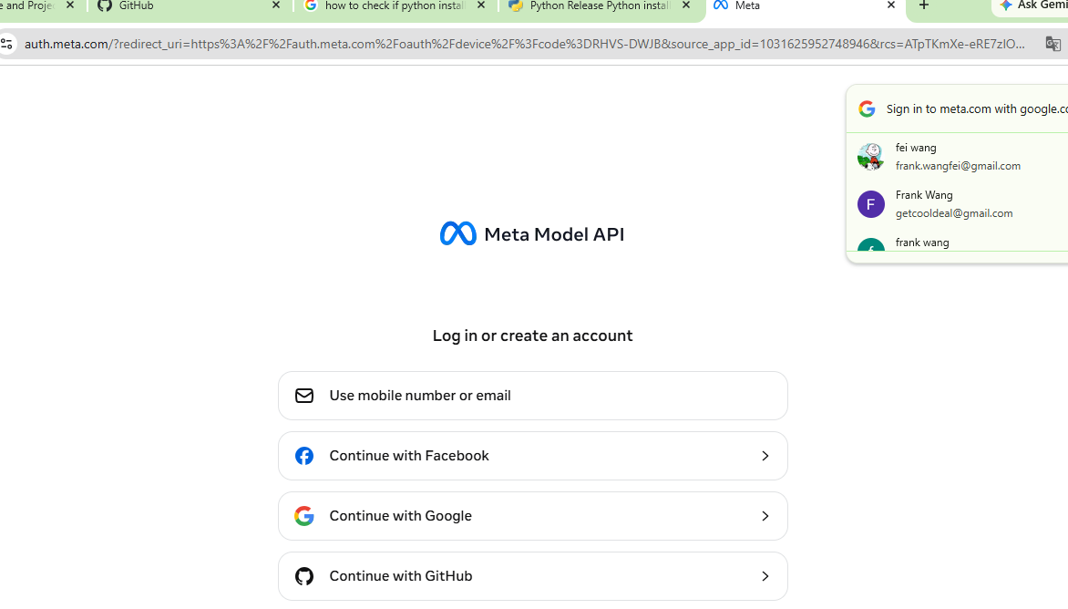
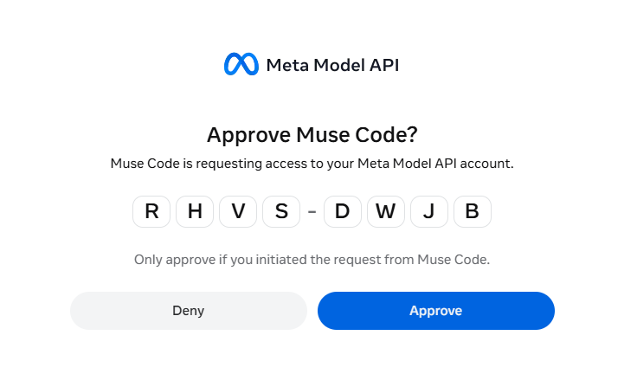

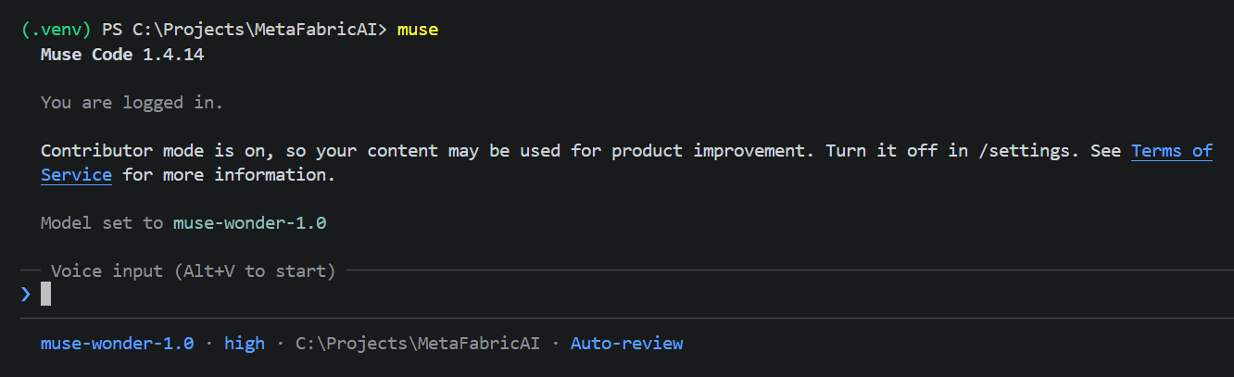

Check your development tools in VS code:
muse --version
node --version
npm --version
python --version
git --version

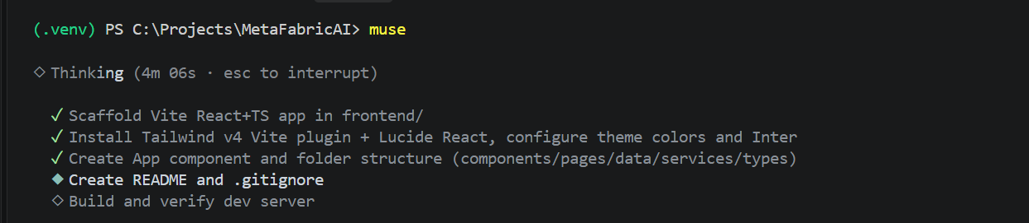
Prompt used:

MetaFabric AI — Phase 1A: Initialize React Frontend
You are helping me develop MetaFabric AI, an AI-powered government open-data discovery website.
Project root: C:\Projects\MetaFabricAI
Existing independent MCP project: C:\Projects\MetadataProject\MetadataMCPServer
My development environment is ready:
- Muse Code 1.4.14
- Node.js 26.13.0
- npm 11.20.0
- Python 3.14.10
- Git 2.56.0

Task
Initialize a modern frontend application inside:
C:\Projects\MetaFabricAI\frontend
Use:
- React
- TypeScript
- Vite
- Tailwind CSS
- Lucide React icons
- Inter font

Instructions
- Inspect the current project structure first.
- If the frontend directory already contains an application, preserve it and report its state rather than overwriting it.
- If no frontend exists, initialize a new React + TypeScript Vite application.
- Install and configure Tailwind CSS using a version-compatible Vite integration.
- Install Lucide React.
- Set up the following design colors:
  - Navy: #10365B
  - Teal: #0D8389
  - Background: #F7FAFC
  - White: #FFFFFF
  - Slate: #64748B
- Create a basic App component showing "MetaFabric AI" and the subtitle "Government Open Data Intelligence".
- Create a clean frontend folder structure for components, pages, data, services, and types.
- Create or update the project README with instructions for running the frontend.
- Create or update .gitignore to exclude node_modules, dist, .venv, .env, and secrets.
- Do not modify files outside C:\Projects\MetaFabricAI.
- Do not connect the MCP server or Meta Model API yet.
- Run the build and fix any configuration or TypeScript errors.
At the end, report the created files, dependencies installed, and exact commands to launch the website.
Implement only the frontend foundation in this step. Do not build the entire dashboard yet.
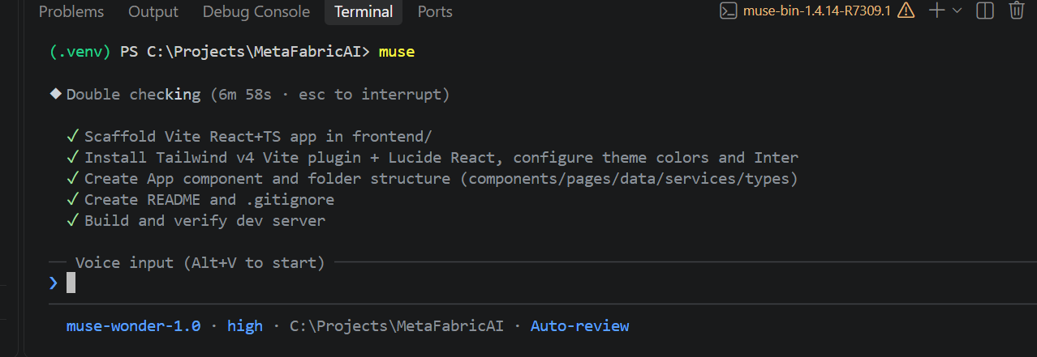
◆ Ran Get-ChildItem -Force -Path 'C:\Projects\MetaFabricAI' | Select-Object Mode, Length, Name; Write-Host "---… — failed
└ windows_elevated unified exec session launcher unavailable: sandbox enforcement unavailable: Windows sandbox setup un
available: admit deny-read state C:\Users\frank.wang\.local\share\muse\windows-sandbox/deny_read_acl_state.json: host
metadata ancestor permits unproved ACL/owner mutation

◆ Ran command · List workspace contents · ✗ · 58s · ctrl+o

◆ Ran command · Inspect MetaFabricAI structure · ✓ · 14s · ctrl+o

◆ Read skill browser-app-delivery · built-in · 10 KB

◆ Ran command · Inspect doc and git state · ✓ · 8.9s · ctrl+o

◆ Read skill taste · built-in · 2 KB

◆ Ran command · Scaffold Vite React TS app · ✓ · 12s · ctrl+o

◆ Ran command · Install deps Tailwind and Lucide · ✓ · 47s · ctrl+o

Read 5 files · ctrl+o

◆ Wrote C:\Projects\MetaFabricAI\frontend\vite.config.ts (+8)
1 +import react from '@vitejs/plugin-react'
2 +import tailwindcss from '@tailwindcss/vite'
3 +import { defineConfig } from 'vite'
4 +
5 +// https://vite.dev/config/
6 +export default defineConfig({
7 + plugins: [react(), tailwindcss()],
8 +})

◆ Wrote C:\Projects\MetaFabricAI\frontend\src\index.css (+29) · ctrl+o
1 +@import "tailwindcss";
2 +
3 +@theme {
4 + --color-navy: #10365b;
5 + --color-teal: #0d8389;
6 + --color-background: #f7fafc;
7 + --color-surface: #ffffff;
8 + --color-slate: #64748b;
9 +
10 + --font-sans: "Inter", ui-sans-system, system-ui, -apple-system, "Segoe UI",
11 + Roboto, "Helvetica Neue", Arial, sans-serif;
12 +}
13 +
14 +html {
15 + font-family: var(--font-sans);
16 +}
17 +
18 +body {
19 + margin: 0;
20 + background-color: var(--color-background);
… 9 more lines

◆ Wrote C:\Projects\MetaFabricAI\frontend\index.html (+23) · ctrl+o
1 +<!doctype html>
2 +<html lang="en">
3 + <head>
4 + <meta charset="UTF-8" />
5 + <link rel="icon" type="image/svg+xml" href="/favicon.svg" />
6 + <meta name="viewport" content="width=device-width, initial-scale=1.0" />
7 + <meta
8 + name="description"
9 + content="MetaFabric AI — Government Open Data Intelligence"
10 + />
11 + <link rel="preconnect" href="https://fonts.googleapis.com" />
12 + <link rel="preconnect" href="https://fonts.gstatic.com" crossorigin />
13 + <link
14 + href="https://fonts.googleapis.com/css2?family=Inter:wght@400;500;600;700;800&display=swap"
15 + rel="stylesheet"
16 + />
17 + <title>MetaFabric AI — Government Open Data Intelligence</title>
18 + </head>
19 + <body>
20 + <div id="root"></div>
… 3 more lines

◆ Ran command · Check src and public files · ✓ · 18s · ctrl+o

◆ Ran command · Create frontend folder structure · ✓ · 5.9s · ctrl+o

◆ Wrote C:\Projects\MetaFabricAI\frontend\src\types\index.ts (+12)
1 +/**
2 + * Shared TypeScript types for MetaFabric AI.
3 + * Domain models (datasets, search results) will be added
4 + * when the Meta Model API is connected in a later phase.
5 + */
6 +export interface Dataset {
7 + id: string;
8 + title: string;
9 + description: string;
10 + source: string;
11 + updatedAt: string;
12 +}

◆ Wrote C:\Projects\MetaFabricAI\frontend\src\services\api.ts (+9)
1 +/**
2 + * API service layer for MetaFabric AI.
3 + *
4 + * Placeholder for Phase 1A — no backend, MCP server, or
5 + * Meta Model API is connected yet. Future phases will add
6 + * typed fetch helpers here using `VITE_API_BASE_URL`.
7 + */
8 +export const API_BASE_URL: string =
9 + import.meta.env.VITE_API_BASE_URL ?? "";

◆ Wrote C:\Projects\MetaFabricAI\frontend\src\data\index.ts (+6)
1 +/**
2 + * Static / local data for MetaFabric AI.
3 + * Placeholder for Phase 1A — sample datasets and filter
4 + * options will live here until a live API is connected.
5 + */
6 +export {};

◆ Wrote C:\Projects\MetaFabricAI\frontend\src\components\Header.tsx (+16)
1 +import { Database } from "lucide-react";
2 +
3 +export default function Header() {
4 + return (
5 + <header className="bg-navy text-white">
6 + <div className="mx-auto flex h-16 w-full max-w-6xl items-center gap-3 px-6">
7 + <span className="flex h-9 w-9 items-center justify-center rounded-md bg-teal">
8 + <Database className="h-5 w-5" aria-hidden="true" />
9 + </span>
10 + <span className="text-base font-semibold tracking-tight">
11 + MetaFabric AI
12 + </span>
13 + </div>
14 + </header>
15 + );
16 +}

◆ Wrote C:\Projects\MetaFabricAI\frontend\src\pages\HomePage.tsx (+26) · ctrl+o
1 +import { Search } from "lucide-react";
2 +
3 +export default function HomePage() {
4 + return (
5 + <main className="mx-auto w-full max-w-6xl px-6 py-16 sm:py-24">
6 + <h1 className="text-4xl font-bold tracking-tight text-navy sm:text-5xl">
7 + MetaFabric AI
8 + </h1>
9 + <p className="mt-3 text-xl font-medium text-teal">
10 + Government Open Data Intelligence
11 + </p>
12 + <p className="mt-5 max-w-2xl text-base leading-relaxed text-slate">
13 + Discover and explore government open datasets through a single,
14 + AI-powered search experience. The discovery dashboard will arrive
15 + in a later phase.
16 + </p>
17 +
18 + <div className="mt-10 flex max-w-xl items-center gap-3 rounded-lg border border-slate/30 bg-surface px-4 py-3
text-slate shadow-sm">
19 + <Search className="h-5 w-5 shrink-0" aria-hidden="true" />
20 + <span className="text-sm">
… 6 more lines

◆ Wrote C:\Projects\MetaFabricAI\frontend\src\App.tsx (+13)
1 +import Header from "./components/Header";
2 +import HomePage from "./pages/HomePage";
3 +
4 +function App() {
5 + return (
6 + <div className="min-h-svh bg-background font-sans">
7 + <Header />
8 + <HomePage />
9 + </div>
10 + );
11 +}
12 +
13 +export default App;

◆ Ran command · Remove empty template assets folder · ✓ · 5.7s · ctrl+o

◆ Wrote C:\Projects\MetaFabricAI\.gitignore (+38) · ctrl+o
1 +# Dependencies
2 +node_modules/
3 +frontend/node_modules/
4 +
5 +# Build output
6 +dist/
7 +frontend/dist/
8 +dist-ssr/
9 +
10 +# Python
11 +.venv/
12 +__pycache__/
13 +*.py[cod]
14 +
15 +# Environment & secrets
16 +.env
17 +.env.*
18 +!.env.example
19 +*.pem
20 +*.key
… 18 more lines

Read C:\Projects\MetaFabricAI\frontend\.gitignore

◆ Edited C:\Projects\MetaFabricAI\frontend\.gitignore (+8 −0)
13 *.local
14 +
15 +# Environment & secrets
16 +.env
17 +.env.*
18 +!.env.example
19 +*.pem
20 +*.key
21 +secrets/

◆ Wrote C:\Projects\MetaFabricAI\README.md (+79) · ctrl+o
1 +# MetaFabric AI
2 +
3 +AI-powered government open-data discovery website.
4 +
5 +**Tagline:** Government Open Data Intelligence
6 +
7 +> Phase 1A — frontend foundation only. The MCP server and Meta Model API
8 +> are not connected yet, and the full discovery dashboard is not built yet.
9 +
10 +## Tech stack (frontend)
11 +
12 +- React 19 + TypeScript
13 +- Vite 8
14 +- Tailwind CSS 4 (via the `@tailwindcss/vite` plugin)
15 +- Lucide React icons
16 +- Inter font (Google Fonts)
17 +
18 +Design colors:
19 +
20 +| Token | Value |
… 59 more lines

◆ Wrote C:\Projects\MetaFabricAI\frontend\README.md (+23) · ctrl+o
1 +# MetaFabric AI — Frontend
2 +
3 +React + TypeScript + Vite frontend for MetaFabric AI
4 +("Government Open Data Intelligence").
5 +
6 +See the [project README](../README.md) for full setup instructions.
7 +
8 +## Quick start
9 +
10 +```powershell
11 +cd C:\Projects\MetaFabricAI\frontend
12 +npm install
13 +npm run dev
14 +```
15 +
16 +Open [http://localhost:5173](http://localhost:5173) in your browser.
17 +
18 +| Command | Description |
19 +| --------------- | ---------------------------------------- |
20 +| `npm run dev` | Start the Vite dev server with HMR |
… 3 more lines

◆ Ran command · Build and lint frontend · ✓ · 33s · ctrl+o

◆ Ran command · Start Vite dev server detached · ✓ · 11s · ctrl+o

◆ Ran command · Check dev server reachability · ✓ · 6.9s · ctrl+o

◆ Ran command · Verify page content and file tree · ✓ · 1m · ctrl+o

◆ Ran command · Remove unused template icons file · ✓ · 6s · ctrl+o

◆ Ran command · Final dev server reachability check · ✓ · 4.3s · ctrl+o

◆ Done — the MetaFabric AI frontend foundation is ready and verified. Open http://localhost:5173 in your browser to view
Intelligence"
• /C:/Projects/MetaFabricAI/frontend/src/types/index.ts, /C:/Projects/MetaFabricAI/frontend/src/services/api.ts
(placeholder, no API yet), /C:/Projects/MetaFabricAI/frontend/src/data/index.ts (placeholder),
/C:/Projects/MetaFabricAI/frontend/README.md, /C:/Projects/MetaFabricAI/frontend/.gitignore

◆ Worked for 7m 11s · 12:16 PM · 31/Oct
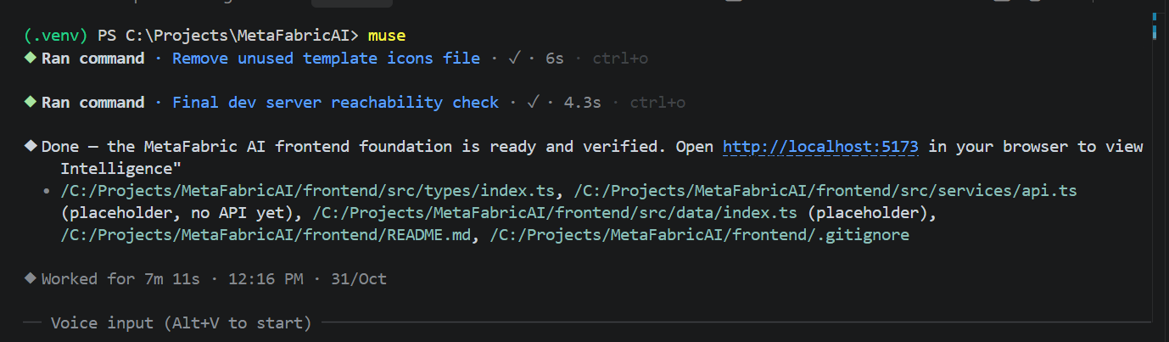
Result:
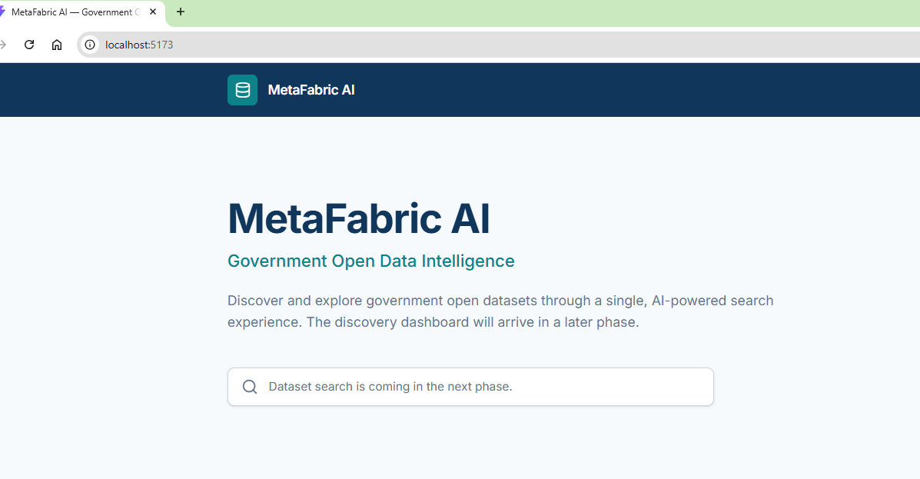

Next Step Prompts:

MetaFabric AI — Phase 1B: Build Dashboard
The React frontend foundation is now initialized.
Implement the MetaFabric AI dashboard using our approved design.

Layout
Create three desktop columns:
- Left navigation: 15%
- Middle research workspace: 62%
- Right AI assistant: 23%
Keep the middle workspace widest. Use responsive CSS Grid with appropriate minimum widths and collapsing panels for smaller screens.

Color scheme
- Navy: #10365B
- Teal: #0D8389
- Background: #F7FAFC
- White cards: #FFFFFF
- Slate: #64748B

Left sidebar
Include Dashboard, Datasets, Saved Recipes, and Federal/State/Local data source filters.

Middle research workspace
Create:
- Explore Government Data search field.
- Example question chips for Flood Risks, Public Health, and Infrastructure.
- Mission interpretation chips showing the research objective, geographic focus, and information needed.
- AI Data Fabric summary explaining the proposed dataset selection strategy.
- Recommended Datasets grouped by purpose.
- Data Gaps and Limitations.
- Excluded on Purpose.
- Suggested Analysis Path.
- Generate Data Recipe button.

Recommended Dataset cards
Include:
- Title and source
- Why this dataset was recommended
- Metadata dates and available quality warnings
- Dataset selection checkbox
- Expandable metadata
- The exact AccessURL metadata field
- Visible Open Dataset button
- Copy URL button
Open Dataset should open a valid HTTP/HTTPS AccessURL in a new tab.
If the AccessURL is missing or invalid, disable the buttons.

Right AI Assistant
Create a collapsible assistant panel that visually supports conversational refinements.
Use clearly labeled demo responses for now.

Data Recipe
Create a separate tab displaying selected datasets, a proposed workflow, data gaps, limitations, and potential outputs.
Do not implement actual GIS analysis.

Reference content
If references/Data Fabric Discovery Demo.html exists, study its "AI data fabric" section.
Preserve its useful content features: mission interpretation, dataset groups, relevance explanations, data quality flags, exclusions, data gaps, and suggested workflows.
Do not copy its two-panel comparison layout.

Implementation
Use reusable React components.
Use clearly labeled mock datasets for frontend testing. Do not imply they are live MCP results.
Do not connect Azure MCP or Meta Model API yet.
Run the build, fix errors, and provide instructions for previewing the dashboard.
Worked for 7m 11s · 12:16 PM · 31/Oct

❯ # MetaFabric AI — Phase 1B: Build Dashboard

The React frontend foundation is now initialized.

Implement the MetaFabric AI dashboard using our approved design.

## Layout

Create three desktop columns:

- Left navigation: 15%
- Middle research workspace: 62%
- Right AI assistant: 23%

Keep the middle workspace widest. Use responsive CSS Grid with appropriate minimum widths and collapsing panels for
smaller screens.

## Color scheme

- Navy: #10365B
- Teal: #0D8389
- Background: #F7FAFC
- White cards: #FFFFFF
- Slate: #64748B

## Left sidebar

Include Dashboard, Datasets, Saved Recipes, and Federal/State/Local data source filters.

## Middle research workspace

Create:

1. **Explore Government Data** search field.
2. Example question chips for Flood Risks, Public Health, and Infrastructure.
3. Mission interpretation chips showing the research objective, geographic focus, and information needed.
4. AI Data Fabric summary explaining the proposed dataset selection strategy.
5. Recommended Datasets grouped by purpose.
6. Data Gaps and Limitations.
7. Excluded on Purpose.
8. Suggested Analysis Path.
9. Generate Data Recipe button.

## Recommended Dataset cards

Include:

- Title and source
- Why this dataset was recommended
- Metadata dates and available quality warnings
- Dataset selection checkbox
- Expandable metadata
- The exact `AccessURL` metadata field
- Visible **Open Dataset** button
- Copy URL button

Open Dataset should open a valid HTTP/HTTPS AccessURL in a new tab.

If the AccessURL is missing or invalid, disable the buttons.

## Right AI Assistant

Create a collapsible assistant panel that visually supports conversational refinements.

Use clearly labeled demo responses for now.

## Data Recipe

Create a separate tab displaying selected datasets, a proposed workflow, data gaps, limitations, and potential outputs.

Do not implement actual GIS analysis.

## Reference content

If `references/Data Fabric Discovery Demo.html` exists, study its "AI data fabric" section.

Preserve its useful content features: mission interpretation, dataset groups, relevance explanations, data quality
flags, exclusions, data gaps, and suggested workflows.

Do not copy its two-panel comparison layout.
… output capped

◆ Ran command · Inspect frontend and references · ✓ · 19s · ctrl+o

◆ Ran command · Search for reference HTML file · ✓ · 11s · ctrl+o

Read 5 files · ctrl+o

Loaded 2 skills · ctrl+o

◆ Wrote C:\Projects\MetaFabricAI\frontend\src\types\index.ts (+54) · ctrl+o
1 +export type SourceLevel = "Federal" | "State" | "Local";
2 +
3 +export type AppTab = "dashboard" | "recipe";
4 +
5 +export type SidebarNav = "dashboard" | "datasets" | "saved";
6 +
7 +export interface DatasetMetadata {
8 + issued: string;
9 + modified: string;
10 + temporalCoverage: string;
11 + spatialCoverage: string;
12 + format: string;
13 + license: string;
14 +}
15 +
16 +export interface Dataset {
17 + id: string;
18 + title: string;
19 + source: string;
20 + sourceLevel: SourceLevel;
… 34 more lines

◆ Wrote C:\Projects\MetaFabricAI\frontend\src\services\url.ts (+10)
1 +/** Returns true only for absolute http:// or https:// URLs. */
2 +export function isValidHttpUrl(value: string | undefined): value is string {
3 + if (!value) return false;
4 + try {
5 + const url = new URL(value);
6 + return url.protocol === "http:" || url.protocol === "https:";
7 + } catch {
8 + return false;
9 + }
10 +}

◆ Wrote C:\Projects\MetaFabricAI\frontend\src\data\datasets.ts (+292) · ctrl+o
1 +import type { Dataset } from "../types";
2 +
3 +/**
4 + * Mock datasets for frontend testing only.
5 + * These are clearly labeled demo records — NOT live MCP results.
6 + */
7 +export const mockDatasets: Dataset[] = [
8 + {
9 + id: "fema-nfhl",
10 + title: "National Flood Hazard Layer (NFHL)",
11 + source: "FEMA — Federal Emergency Management Agency",
12 + sourceLevel: "Federal",
13 + description:
14 + "Official flood hazard data including flood insurance rate map zones, base flood elevations, and floodway bou
ndaries.",
15 + whyRecommended:
16 + "Authoritative national flood-hazard footprint. Use it as the hazard layer every other dataset is compared ag
ainst.",
17 + AccessURL: "https://www.fema.gov/flood-maps",
18 + metadata: {
19 + issued: "2015-06-01",
20 + modified: "2026-08-14",
… 272 more lines

◆ Wrote C:\Projects\MetaFabricAI\frontend\src\data\missions.ts (+183) · ctrl+o
1 +import type { Mission } from "../types";
2 +
3 +export const missions: Mission[] = [
4 + {
5 + id: "flood-risks",
6 + label: "Flood Risks",
7 + query: "Which communities face the highest flood risk, and who is most exposed?",
8 + objective: "Assess community flood risk and population exposure",
9 + geographicFocus: "United States, with state and county drill-down",
10 + informationNeeded: [
11 + "Flood hazard footprint",
12 + "Population and housing exposure",
13 + "Observed rainfall and stream history",
14 + "Existing mitigation projects",
15 + ],
16 + fabricSummary:
17 + "Start from the authoritative FEMA hazard footprint, add USGS drainage pathways to explain how water moves, t
hen overlay Census demographics to see who is exposed. State and local records fill planning and observed-event gap
s the national layers cannot cover. Stale or unadopted local data is flagged, never silently merged.",
18 + groups: [
19 + {
20 + purpose: "Hazard & Exposure Footprint",
… 163 more lines

◆ Wrote C:\Projects\MetaFabricAI\frontend\src\components\Header.tsx (+50) · ctrl+o
1 +import { Database } from "lucide-react";
2 +import type { AppTab } from "../types";
3 +
4 +interface HeaderProps {
5 + activeTab: AppTab;
6 + onTabChange: (tab: AppTab) => void;
7 + selectedCount: number;
8 +}
9 +
10 +export default function Header({ activeTab, onTabChange, selectedCount }: HeaderProps) {
11 + const tabClass = (tab: AppTab) =>
12 + `rounded-md px-3 py-1.5 text-sm font-medium transition-colors ${
13 + activeTab === tab
14 + ? "bg-teal text-white"
15 + : "text-white/75 hover:bg-white/10 hover:text-white"
16 + }`;
17 +
18 + return (
19 + <header className="bg-navy text-white">
20 + <div className="flex min-h-16 flex-wrap items-center gap-x-5 gap-y-2 px-4 py-2 sm:px-5">
… 30 more lines

◆ Wrote C:\Projects\MetaFabricAI\frontend\src\components\Sidebar.tsx (+86) · ctrl+o
1 +import { Bookmark, Database, LayoutDashboard } from "lucide-react";
2 +import type { SidebarNav, SourceLevel } from "../types";
3 +
4 +interface SidebarProps {
5 + activeNav: SidebarNav;
6 + onNavigate: (nav: SidebarNav) => void;
7 + sourceLevels: Set<SourceLevel>;
8 + onToggleSourceLevel: (level: SourceLevel) => void;
9 + countsByLevel: Record<SourceLevel, number>;
10 + selectedCount: number;
11 +}
12 +
13 +const NAV_ITEMS: { id: SidebarNav; label: string; icon: typeof LayoutDashboard }[] = [
14 + { id: "dashboard", label: "Dashboard", icon: LayoutDashboard },
15 + { id: "datasets", label: "Datasets", icon: Database },
16 + { id: "saved", label: "Saved Recipes", icon: Bookmark },
17 +];
18 +
19 +const LEVELS: SourceLevel[] = ["Federal", "State", "Local"];
20 +
… 66 more lines

◆ Wrote C:\Projects\MetaFabricAI\frontend\src\components\DatasetCard.tsx (+191) · ctrl+o
1 +import { useState } from "react";
2 +import {
3 + AlertTriangle,
4 + CalendarDays,
5 + Check,
6 + ChevronDown,
7 + Copy,
8 + ExternalLink,
9 +} from "lucide-react";
10 +import type { Dataset } from "../types";
11 +import { isValidHttpUrl } from "../services/url";
12 +
13 +interface DatasetCardProps {
14 + dataset: Dataset;
15 + selected: boolean;
16 + onToggleSelected: (id: string) => void;
17 +}
18 +
19 +export default function DatasetCard({ dataset, selected, onToggleSelected }: DatasetCardProps) {
20 + const [expanded, setExpanded] = useState(false);
… 171 more lines

◆ Wrote C:\Projects\MetaFabricAI\frontend\src\components\AIAssistant.tsx (+163) · ctrl+o
1 +import { useState } from "react";
2 +import type { FormEvent } from "react";
3 +import { Bot, ChevronRight, PanelRightClose, Send, User } from "lucide-react";
4 +import type { Mission } from "../types";
5 +
6 +interface AIAssistantProps {
7 + collapsed: boolean;
8 + onToggleCollapsed: () => void;
9 + mission: Mission;
10 +}
11 +
12 +interface Message {
13 + id: number;
14 + role: "user" | "assistant";
15 + text: string;
16 +}
17 +
18 +const QUICK_REFINEMENTS = [
19 + "Narrow to county level",
20 + "Federal sources only",
… 143 more lines

◆ Wrote C:\Projects\MetaFabricAI\frontend\src\pages\DashboardPage.tsx (+286) · ctrl+o
1 +import type { FormEvent, ReactNode } from "react";
2 +import {
3 + Ban,
4 + ClipboardList,
5 + Crosshair,
6 + FileSearch,
7 + Info,
8 + Layers,
9 + ListOrdered,
10 + MapPin,
11 + Search,
12 + Sparkles,
13 + Target,
14 + TriangleAlert,
15 + WandSparkles,
16 +} from "lucide-react";
17 +import type { Dataset, Mission, SourceLevel } from "../types";
18 +import { getDatasetById } from "../data/datasets";
19 +import DatasetCard from "../components/DatasetCard";
20 +
… 266 more lines

◆ Wrote C:\Projects\MetaFabricAI\frontend\src\pages\DataRecipePage.tsx (+175) · ctrl+o
1 +import {
2 + ArrowLeft,
3 + ExternalLink,
4 + FileOutput,
5 + Info,
6 + ListOrdered,
7 + TriangleAlert,
8 + X,
9 +} from "lucide-react";
10 +import type { Dataset, Mission } from "../types";
11 +import { isValidHttpUrl } from "../services/url";
12 +
13 +interface DataRecipePageProps {
14 + mission: Mission;
15 + selectedDatasets: Dataset[];
16 + onRemoveDataset: (id: string) => void;
17 + onBackToWorkspace: () => void;
18 +}
19 +
20 +export default function DataRecipePage({
… 155 more lines

◆ Edited C:\Projects\MetaFabricAI\frontend\src\index.css (+43 −0) · ctrl+o
29 }
30 +
31 +/* Dashboard layout: left nav 15% / workspace 62% / assistant 23% on desktop.
32 + fr units keep the ratio exact once the gap is subtracted. */
33 +.dashboard-grid {
34 + display: grid;
35 + grid-template-columns: minmax(0, 1fr);
36 + gap: 1rem;
37 + padding: 1rem;
38 + align-items: start;
39 +}
40 +
41 +@media (min-width: 1024px) {
42 + .dashboard-grid {
43 + grid-template-columns: minmax(180px, 15fr) minmax(0, 85fr);
44 + }
45 + .dashboard-grid > .grid-assistant {
46 + grid-column: 1 / -1;
47 + }
48 +}
… 24 more lines

◆ Wrote C:\Projects\MetaFabricAI\frontend\src\App.tsx (+144) · ctrl+o
1 +import { useMemo, useState } from "react";
2 +import Header from "./components/Header";
3 +import Sidebar from "./components/Sidebar";
4 +import AIAssistant from "./components/AIAssistant";
5 +import DashboardPage from "./pages/DashboardPage";
6 +import DataRecipePage from "./pages/DataRecipePage";
7 +import { defaultMission, missions } from "./data/missions";
8 +import { getDatasetById, mockDatasets } from "./data/datasets";
9 +import type { AppTab, Dataset, Mission, SidebarNav, SourceLevel } from "./types";
10 +
11 +const ALL_LEVELS: SourceLevel[] = ["Federal", "State", "Local"];
12 +
13 +function App() {
14 + const [activeTab, setActiveTab] = useState<AppTab>("dashboard");
15 + const [activeNav, setActiveNav] = useState<SidebarNav>("dashboard");
16 + const [mission, setMission] = useState<Mission>(defaultMission);
17 + const [query, setQuery] = useState(defaultMission.query);
18 + const [sourceLevels, setSourceLevels] = useState<Set<SourceLevel>>(
19 + () => new Set(ALL_LEVELS),
20 + );
… 124 more lines

◆ Ran command · Remove old HomePage and build · ✓ · 40s · ctrl+o

◆ Ran command · Check bundle content and server port · ✓ · 1m · ctrl+o

◆ Ran command · Verify all dashboard strings in bundle · ✓ · 12s · ctrl+o

Read C:\Projects\MetaFabricAI\README.md

◆ Edited C:\Projects\MetaFabricAI\README.md (+18 −2)
7 -> Phase 1A — frontend foundation only. The MCP server and Meta Model API
8 -> are not connected yet, and the full discovery dashboard is not built yet.
7 +> Phase 1B — dashboard built with clearly labeled mock datasets for
8 +> frontend testing. No Azure MCP or Meta Model API is connected yet, and
9 +> no GIS analysis is performed.
10 +
11 +## Dashboard preview
12 +
13 +After `npm run dev`, open [http://localhost:5173](http://localhost:5173):
14 +
15 +- **Left (15%)** — Dashboard / Datasets / Saved Recipes navigation and
16 + Federal / State / Local source filters.
17 +- **Middle (62%)** — Explore Government Data search, example missions
18 + (Flood Risks, Public Health, Infrastructure), mission interpretation,
19 + AI Data Fabric summary, grouped Recommended Datasets with `AccessURL`
20 + links, Data Gaps, Excluded on Purpose, and Suggested Analysis Path.
21 +- **Right (23%)** — collapsible AI Assistant with labeled demo responses.
22 +- **Data Recipe tab** — selected datasets, proposed workflow, gaps,
23 + limitations, and potential outputs. Tick dataset checkboxes, then use
24 + **Generate Data Recipe**.

◆ Edited C:\Projects\MetaFabricAI\README.md (+4 −4)
77 -│ ├── components/ # reusable UI components (e.g. Header)
78 -│ ├── pages/ # route-level pages (e.g. HomePage)
79 -│ ├── data/ # static / local data (placeholder)
80 -│ ├── services/ # API service layer (placeholder, no API yet)
77 +│ ├── components/ # Header, Sidebar, DatasetCard, AIAssistant
78 +│ ├── pages/ # DashboardPage, DataRecipePage
79 +│ ├── data/ # mock missions + datasets (demo, not live MCP)
80 +│ ├── services/ # API placeholder + URL validation helper

◆ Ran command · Final dev server reachability check · ✓ · 3.8s · ctrl+o

◆ Done — the dashboard is built and verified. Open http://localhost:5173 in your browser to preview it (dev server
returned HTTP 200 just now).

Started with: npm run dev from /C:/Projects/MetaFabricAI/frontend

Preview from scratch

cd C:\Projects\MetaFabricAI\frontend
npm install
npm run dev

Then open http://localhost:5173 in your browser.

Verification

• npm run build passed with no TypeScript errors, and npm run lint passed with 0 warnings.
• Bundle check confirmed all dashboard sections, example missions, and AccessURL controls are present in the built
output.
• The running dev server serves the new workspace code. Interactions (chip switching, filtering, checkbox selection,
copy feedback) were not exercised in a real browser — check them on the page above.

What was built

• Layout in /C:/Projects/MetaFabricAI/frontend/src/App.tsx and /C:/Projects/MetaFabricAI/frontend/src/index.css:
responsive CSS Grid at 15% / 62% / 23% (left / middle / right, middle widest) on wide screens, with minimum widths,
stacking on small screens, and a collapsed-assistant variant.
• Left: /C:/Projects/MetaFabricAI/frontend/src/components/Sidebar.tsx with Dashboard, Datasets, Saved Recipes, and
Federal/State/Local filters that actually filter the cards.
• Middle: /C:/Projects/MetaFabricAI/frontend/src/pages/DashboardPage.tsx with Explore Government Data search, Flood
Risks / Public Health / Infrastructure chips (each swaps the mission, datasets, gaps, exclusions, and path), mission
interpretation chips, AI Data Fabric summary, grouped datasets, Data Gaps and Limitations, Excluded on Purpose,
Suggested Analysis Path, and a Generate Data Recipe button that is disabled until a dataset is selected.
• Cards: /C:/Projects/MetaFabricAI/frontend/src/components/DatasetCard.tsx with title/source, recommendation reason,
issued/modified dates, quality warnings, selection checkbox, expandable metadata, and the exact AccessURL field. Open
Dataset opens a valid HTTP/HTTPS URL in a new tab; Copy URL uses the clipboard. Missing or invalid URLs disable both
buttons — two mock records demonstrate those states.
• Right: /C:/Projects/MetaFabricAI/frontend/src/components/AIAssistant.tsx, collapsible to an icon rail, with quick
refinements and a working input that returns clearly labeled "Demo response" replies.
• Recipe tab: /C:/Projects/MetaFabricAI/frontend/src/pages/DataRecipePage.tsx with selected datasets, proposed
workflow, data gaps, limitations drawn from selected cards, and potential outputs. No GIS analysis is implemented.
• Mock content in /C:/Projects/MetaFabricAI/frontend/src/data/datasets.ts and
/C:/Projects/MetaFabricAI/frontend/src/data/missions.ts, labeled "Mock"/"Demo data" throughout. No Azure MCP or Meta
Model API is connected.

One note: references/Data Fabric Discovery Demo.html does not exist in the workspace, so its two-panel layout was not
copied; its listed content features (mission interpretation, dataset groups, relevance explanations, quality flags,
exclusions, gaps, suggested workflows) were implemented from your specification instead.

◆ Worked for 5m 58s · 12:27 PM · 31/Oct

◆ Recap: Goal is MetaFabric AI discovery dashboard and Phase 1B is complete with verified build. Next open
http://localhost:5173 to preview and confirm interactions.

==
Check in code to git
git config --local user.name "Jonathan"
git config --local user.email "jonxiangxiang@outlook.com"

follow steps defined in https://chatgpt.com/g/g-p-6ac59390aac881919097bb7cc9ffa922-python-and-vs-code/c/6ac9943a-ff30-83ea-8d85-d314bed34835
to push code and create release
(.venv) PS C:\Projects\MetaFabricAI> git config --local user.name "Jonathan"

(.venv) PS C:\Projects\MetaFabricAI> git config --local user.email "jonxiangxiang@outlook.com"
(.venv) PS C:\Projects\MetaFabricAI> git config user.name
>> git config user.email
Jonathan
jonxiangxiang@outlook.com
(.venv) PS C:\Projects\MetaFabricAI> git branch -M main
(.venv) PS C:\Projects\MetaFabricAI> git add -n .
add '.gitignore'
add 'README.md'
add 'doc/Set up Development environment for MetaFabricAI.docx'
add 'doc/~$t up Development environment for MetaFabricAI.docx'
add 'doc/~WRL0005.tmp'
add 'frontend/.gitignore'
add 'frontend/.oxlintrc.json'
add 'frontend/README.md'
add 'frontend/index.html'
add 'frontend/package-lock.json'
add 'frontend/package.json'
add 'frontend/public/favicon.svg'
add 'frontend/src/App.tsx'
add 'frontend/src/components/AIAssistant.tsx'
add 'frontend/src/components/DatasetCard.tsx'
add 'frontend/src/components/Header.tsx'
add 'frontend/src/components/Sidebar.tsx'
add 'frontend/src/data/datasets.ts'
add 'frontend/src/data/index.ts'
add 'frontend/src/data/missions.ts'
add 'frontend/src/index.css'
add 'frontend/src/main.tsx'
add 'frontend/src/pages/DashboardPage.tsx'
add 'frontend/src/pages/DataRecipePage.tsx'
add 'frontend/src/services/api.ts'
add 'frontend/src/services/url.ts'
add 'frontend/src/types/index.ts'
add 'frontend/tsconfig.app.json'
add 'frontend/tsconfig.json'
add 'frontend/tsconfig.node.json'
add 'frontend/vite.config.ts'
(.venv) PS C:\Projects\MetaFabricAI> git add .
warning: in the working copy of '.gitignore', LF will be replaced by CRLF the next time Git touches it
warning: in the working copy of 'README.md', LF will be replaced by CRLF the next time Git touches it
warning: in the working copy of 'frontend/.gitignore', LF will be replaced by CRLF the next time Git touches it
warning: in the working copy of 'frontend/.oxlintrc.json', LF will be replaced by CRLF the next time Git touches it
warning: in the working copy of 'frontend/README.md', LF will be replaced by CRLF the next time Git touches it
warning: in the working copy of 'frontend/index.html', LF will be replaced by CRLF the next time Git touches it
warning: in the working copy of 'frontend/package-lock.json', LF will be replaced by CRLF the next time Git touches it
warning: in the working copy of 'frontend/package.json', LF will be replaced by CRLF the next time Git touches it
warning: in the working copy of 'frontend/src/App.tsx', LF will be replaced by CRLF the next time Git touches it
warning: in the working copy of 'frontend/src/components/AIAssistant.tsx', LF will be replaced by CRLF the next time Git touches it
warning: in the working copy of 'frontend/src/components/DatasetCard.tsx', LF will be replaced by CRLF the next time Git touches it
warning: in the working copy of 'frontend/src/components/Header.tsx', LF will be replaced by CRLF the next time Git touches it
warning: in the working copy of 'frontend/src/components/Sidebar.tsx', LF will be replaced by CRLF the next time Git touches it
warning: in the working copy of 'frontend/src/data/datasets.ts', LF will be replaced by CRLF the next time Git touches it
warning: in the working copy of 'frontend/src/data/index.ts', LF will be replaced by CRLF the next time Git touches it
warning: in the working copy of 'frontend/src/data/missions.ts', LF will be replaced by CRLF the next time Git touches it
warning: in the working copy of 'frontend/src/index.css', LF will be replaced by CRLF the next time Git touches it
warning: in the working copy of 'frontend/src/main.tsx', LF will be replaced by CRLF the next time Git touches it
warning: in the working copy of 'frontend/src/pages/DashboardPage.tsx', LF will be replaced by CRLF the next time Git touches it
warning: in the working copy of 'frontend/src/pages/DataRecipePage.tsx', LF will be replaced by CRLF the next time Git touches it
warning: in the working copy of 'frontend/src/services/api.ts', LF will be replaced by CRLF the next time Git touches it
warning: in the working copy of 'frontend/src/services/url.ts', LF will be replaced by CRLF the next time Git touches it
warning: in the working copy of 'frontend/src/types/index.ts', LF will be replaced by CRLF the next time Git touches it
warning: in the working copy of 'frontend/tsconfig.app.json', LF will be replaced by CRLF the next time Git touches it
warning: in the working copy of 'frontend/tsconfig.json', LF will be replaced by CRLF the next time Git touches it
warning: in the working copy of 'frontend/tsconfig.node.json', LF will be replaced by CRLF the next time Git touches it
warning: in the working copy of 'frontend/vite.config.ts', LF will be replaced by CRLF the next time Git touches it
(.venv) PS C:\Projects\MetaFabricAI> git status
On branch main

No commits yet

Changes to be committed:
(use "git rm --cached <file>..." to unstage)
new file: .gitignore
new file: README.md
new file: doc/Set up Development environment for MetaFabricAI.docx
new file: doc/~$t up Development environment for MetaFabricAI.docx
new file: doc/~WRL0005.tmp
new file: frontend/.gitignore
new file: frontend/.oxlintrc.json
new file: frontend/README.md
new file: frontend/index.html
new file: frontend/package-lock.json
new file: frontend/package.json
new file: frontend/public/favicon.svg
new file: frontend/src/App.tsx
new file: frontend/src/components/AIAssistant.tsx
new file: frontend/src/components/DatasetCard.tsx
new file: frontend/src/components/Header.tsx
new file: frontend/src/components/Sidebar.tsx
new file: frontend/src/data/datasets.ts
new file: frontend/src/data/index.ts
new file: frontend/src/data/missions.ts
new file: frontend/src/index.css
new file: frontend/src/main.tsx
new file: frontend/src/pages/DashboardPage.tsx
new file: frontend/src/pages/DataRecipePage.tsx
new file: frontend/src/services/api.ts
new file: frontend/src/services/url.ts
new file: frontend/src/types/index.ts
new file: frontend/tsconfig.app.json
new file: frontend/tsconfig.json
new file: frontend/tsconfig.node.json
new file: frontend/vite.config.ts

(.venv) PS C:\Projects\MetaFabricAI> git add .
(.venv) PS C:\Projects\MetaFabricAI> git status
On branch main

No commits yet

Changes to be committed:
(use "git rm --cached <file>..." to unstage)
new file: .gitignore
new file: README.md
new file: doc/Set up Development environment for MetaFabricAI.docx
new file: doc/~$t up Development environment for MetaFabricAI.docx
new file: doc/~WRL0005.tmp
new file: frontend/.gitignore
new file: frontend/.oxlintrc.json
new file: frontend/README.md
new file: frontend/index.html
new file: frontend/package-lock.json
new file: frontend/package.json
new file: frontend/public/favicon.svg
new file: frontend/src/App.tsx
new file: frontend/src/components/AIAssistant.tsx
new file: frontend/src/components/DatasetCard.tsx
new file: frontend/src/components/Header.tsx
new file: frontend/src/components/Sidebar.tsx
new file: frontend/src/data/datasets.ts
new file: frontend/src/data/index.ts
new file: frontend/src/data/missions.ts
new file: frontend/src/index.css
new file: frontend/src/main.tsx
new file: frontend/src/pages/DashboardPage.tsx
new file: frontend/src/pages/DataRecipePage.tsx
new file: frontend/src/services/api.ts
new file: frontend/src/services/url.ts
new file: frontend/src/types/index.ts
new file: frontend/tsconfig.app.json
new file: frontend/tsconfig.json
new file: frontend/tsconfig.node.json
new file: frontend/vite.config.ts

(.venv) PS C:\Projects\MetaFabricAI> git commit -m "v0.1.0: Initial MetaFabricAI version using demo data"
[main (root-commit) 395dfce] v0.1.0: Initial MetaFabricAI version using demo data
31 files changed, 4440 insertions(+)
create mode 100644 .gitignore
create mode 100644 README.md
create mode 100644 doc/Set up Development environment for MetaFabricAI.docx
create mode 100644 doc/~$t up Development environment for MetaFabricAI.docx
create mode 100644 doc/~WRL0005.tmp
create mode 100644 frontend/.gitignore
create mode 100644 frontend/.oxlintrc.json
create mode 100644 frontend/README.md
create mode 100644 frontend/index.html
create mode 100644 frontend/package-lock.json
create mode 100644 frontend/package.json
create mode 100644 frontend/public/favicon.svg
create mode 100644 frontend/src/App.tsx
create mode 100644 frontend/src/components/AIAssistant.tsx
create mode 100644 frontend/src/components/DatasetCard.tsx
create mode 100644 frontend/src/components/Header.tsx
create mode 100644 frontend/src/components/Sidebar.tsx
create mode 100644 frontend/src/data/datasets.ts
create mode 100644 frontend/src/data/index.ts
create mode 100644 frontend/src/data/missions.ts
create mode 100644 frontend/src/index.css
create mode 100644 frontend/src/main.tsx
create mode 100644 frontend/src/pages/DashboardPage.tsx
create mode 100644 frontend/src/pages/DataRecipePage.tsx
create mode 100644 frontend/src/services/api.ts
create mode 100644 frontend/src/services/url.ts
create mode 100644 frontend/src/types/index.ts
create mode 100644 frontend/tsconfig.app.json
create mode 100644 frontend/tsconfig.json
create mode 100644 frontend/tsconfig.node.json
create mode 100644 frontend/vite.config.ts
(.venv) PS C:\Projects\MetaFabricAI> git tag -a v0.1.0-demo -m "MetaFabricAI first version using demo data"
(.venv) PS C:\Projects\MetaFabricAI> git tag -n
v0.1.0-demo MetaFabricAI first version using demo data
(.venv) PS C:\Projects\MetaFabricAI> git remote add origin https://github.com/BruhWhosJoe/MetaFabricAI.git
(.venv) PS C:\Projects\MetaFabricAI> git push origin main
info: please complete authentication in your browser...
Enumerating objects: 42, done.
Counting objects: 100% (42/42), done.
Delta compression using up to 6 threads
Compressing objects: 100% (40/40), done.
Writing objects: 100% (42/42), 808.81 KiB | 6.91 MiB/s, done.
Total 42 (delta 2), reused 0 (delta 0), pack-reused 0 (from 0)
remote: Resolving deltas: 100% (2/2), done.
To https://github.com/BruhWhosJoe/MetaFabricAI.git
* [new branch] main -> main
(.venv) PS C:\Projects\MetaFabricAI> git push origin v0.1.0-demo
Enumerating objects: 1, done.
Counting objects: 100% (1/1), done.
Writing objects: 100% (1/1), 194 bytes | 97.00 KiB/s, done.
Total 1 (delta 0), reused 0 (delta 0), pack-reused 0 (from 0)
To https://github.com/BruhWhosJoe/MetaFabricAI.git
* [new tag] v0.1.0-demo -> v0.1.0-demo
(.venv) PS C:\Projects\MetaFabricAI>
Create a Github Release



